Exam

- Write a function that will make simple value Exchange rate (exchange rate constant = 0.70) in a separate php file ($var1 = $var2 * EXCHANGE_RATE;), user input, and button.
  - Write a html or php page that will call that function and display the result.
- Write a function that will read from a local text file (Exam.txt) and display the result in html control.
- In php Create a cookie named “sIndex” and write your ID number in it (write from code). Afterwards display on another page referenced with a button (GET or POST).
- Make a self-referencing PHP page that accepts the input and uses it to display a color swatch:
  - <div style="width:150px; height: 150px;
background-color: rgb(<?php echo $rgb; ?>)" />
- Make a registration page:
  - This form has five input fields, one each for the applicant’s name, address, age,
profession, and residential status
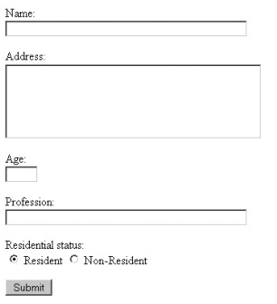
Reservation should be written to database table.

